Djibouti

## Respect for rule of law (ROL) data

The data set shows the data on the respect of the rule of law for the country.

## # A tibble: 19 x 5  
## country iso3c date ruleOfLaw ruleOfLawCategory4   
## <chr> <chr> <dbl> <dbl> <chr>   
## 1 Djibouti DJI 1996 -0.972 ROL moderately disrespected  
## 2 Djibouti DJI 1998 -0.847 ROL moderately disrespected  
## 3 Djibouti DJI 2000 -0.886 ROL moderately disrespected  
## 4 Djibouti DJI 2002 -0.917 ROL moderately disrespected  
## 5 Djibouti DJI 2003 -0.867 ROL moderately disrespected  
## 6 Djibouti DJI 2004 -0.851 ROL moderately disrespected  
## 7 Djibouti DJI 2005 -0.957 ROL moderately disrespected  
## 8 Djibouti DJI 2006 -0.877 ROL moderately disrespected  
## 9 Djibouti DJI 2007 -0.756 ROL moderately disrespected  
## 10 Djibouti DJI 2008 -0.645 ROL moderately disrespected  
## 11 Djibouti DJI 2009 -0.677 ROL moderately disrespected  
## 12 Djibouti DJI 2010 -0.729 ROL moderately disrespected  
## 13 Djibouti DJI 2011 -0.807 ROL moderately disrespected  
## 14 Djibouti DJI 2012 -0.791 ROL moderately disrespected  
## 15 Djibouti DJI 2013 -0.772 ROL moderately disrespected  
## 16 Djibouti DJI 2014 -0.874 ROL moderately disrespected  
## 17 Djibouti DJI 2015 -0.922 ROL moderately disrespected  
## 18 Djibouti DJI 2016 -0.976 ROL moderately disrespected  
## 19 Djibouti DJI 2017 -0.913 ROL moderately disrespected

## Respect for rule of law (ROL) trend

The plot shows the trend of the respect for the rule of law for the country.

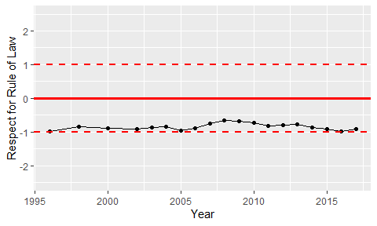

Trend of the Respect for the Rule of Law